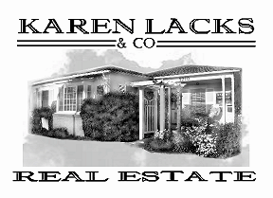

Karen D. Lacks Ramstrum, Broker
DRE #00576880
5210 Carpinteria Ave, Carpinteria, Ca 93013
Office: (805) 684-7559 Fax: (805) 684-7580

June 4,, 2026

Elisabeth Shima
338 Oliver Road
Santa Barbara, CA 93109

Re: 289 Ellwood Beach Drive

Dear Aliza,

Please find attached the Comparative Market Analysis for the apartment building located at 289 Ellwood Beach Drive. I applied the following considerations when evaluating the market value of your property as of March 24, 2026: number of units, number of bedrooms and bathrooms, age, condition/upgrades, square footage, lot size, property amenities and neighborhood. I compared similar properties that were actively marketed for sale, pending or closed within the prior 18 months.

The Comparative Market Analysis shows 5 properties that best match the subject property. 289 Ellwood Beach Drive consists of 12 units: 11 -1 bedroom apartments and 1 studio apartment, with 3 carports and 8 parking spaces.

My opinion of value for 289 Ellwood Beach Drive was $4,675,000 on March 24, 2026.

Should you need more information, I will be happy to provide it to you.

Sincerely,

Karen L. Ramstrum
Karen Lacks & Co. Real Estate

Enclosures

